Page 1
First of all, you will excuse this broken English.
Mine being too average, I used an automatic translator.
THANKS
A player since the game's release in 1998, through hundreds of team and AI games I have learned to avoid traps and improve my combat and commander technique.
I am not and have never sought to be the best.
Being good is enough to enjoy the game.
Battlezone is a game that mainly focuses on strategy, the best "Fighters" are not necessarily the smartest...

NB: Battlezone continues to evolve thanks to passionate “Modders” whom I thank. Their work is remarkable, however these developments no longer have anything to do with the original game. There is no more strategy, all that remains is fighting against incessant and countless waves of enemies.
Don't start with these mods, a new player has no chance of finishing a game or having fun.

So let me give you some tips for getting started in Battlezone Combat Commander

Have Fun, Ras-French {FCX}

New to BZ ? A word of advice…
The 1st advice if you are new to BZ, play the game's campaign. Like all games, the campaign is progressive and allows you to familiarize yourself with the game and the controls.
If you don't do it, you risk quickly being disappointed because you will often lose, even in MPI against the AI...
Rules of the BZ II "stock" game - players against players (strategy cards)
Like any game, BZ II obeys precise rules whose sole purpose is to make the games fairer.
The use of game "defects/bugs", "cheats", the practice of "tabulation/tabbing", etc., is of course prohibited
NB: These rules are not “official”.
They were established by the vast majority of players and different teams at the release of the game in order to maintain a balance in our games. Certain bugs in the game can be very unfavorable for this balance.
It is obvious that since the 2000s, the game has evolved and that most of these bugs have been resolved, so these rules do not apply to the latest patches, but to the "Stock" version of Battlezone.

Here is what is forbidden to do in game players against players:
• Place turrets in pools or in buildings.
• Build a building on a turret or outside the game map.
• Enter enemy buildings with your ship to destroy it.
• Kill the enemy on foot... (you only kill an enemy on foot once, in order to remove his snipe)
• Exit and re-enter voluntarily to get a new ship. • To pilot the “motor-mortars”. (no human driver in this vehicle!). • Attack the first two enemy scavenger before they are deployed. (or push them into a ravine or water!)
By respecting these few rules of good conduct, you will have great games and will be respected by other players.

Page 2

Various aids
Change view
________________________________________
• Shift + f1 = interior view
• Shift + f2 = close exterior view
• Shift + f3 = distant exterior view
• Shift + f4 = cockpit view
________________________________________

Form groups of units
If you group different ships, you will no longer have the ship icon but the energy icon : 
For example, if you want to group a turret in F1 with another in F2 select F2 then Ctrl + F1, you will thus have two turrets in F1 and so on.
Supply your partners with ships

Whether you are the commander or not, you can give ships to your partners.
Select the ship (e.g. F5) then press Ctrl + the key corresponding to the desired partner (e.g. F9) and the ship moves from your screen to that of your playing partner.

Page 3

Building an effective base

• Never build the factory next to the recycler in the event of an attack both would be damaged at the same time, especially with the bomber.
• Same advice for energies. Try not to group them.
Just one bomb on it and you lose too many. Buildings and Defenses will then be inactive due to lack of energy.
Build energies in a dispersed manner.
Also build, if possible, 2 or 3 additional energies.
In MPI, especially if you play alone, you risk a massive attack while you are far from your base. Having extra energy allows you to power your cannon towers longer and thus save your base.
• The repair area: always build it so that it is easily accessible. You can guide your buildings to construction with the ² key
• The Factory: Orient the factory so that your ships can have room to be stored and leave the base easily.
Don't build anything in front of the factory exit!
• Defenses: From the start of the game and especially in MPI alone, look at your environment before deploying the recycler. Try to determine where the enemies will arrive.
Then deploy the recycler so that there is enough room to build the gun towers, the relay bunker, and enough room to move between the defenses and the recycler. You will have a lot of units later and they will need to be able to move around.
We have already seen games lost because the units were "stuck" between buildings, scavenger, repair trucks, etc. By the time everything was untangled, a bomber had destroyed everything...
• Build enough gun towers to hold off enemy assault waves, because in MPI alone you will often go far away in search of pools or other locations.
Last advice, position a few turrets at the back of the base, some clever enemies can bypass your defenses.
Once safe from your buildings, they will attack your energies to deactivate the defenses.
• Priorities of enemy attacks in your base: Generally speaking, enemies attack your scavengers or the relay bunker first, the energies and then the cannon towers.
Their priority is to reduce your resources, disable your defenses before attacking the buildings.
Obviously, this can vary depending on the configuration of the terrain, your base and the elements present.
• Do not release too many pods in advance but only when one of your warriors arrives at your base.
If necessary, your teammates must ask you for them before arriving at the base.
Do not obstruct the passage towards the front of the recycler with turrets or buildings, because when you return to your base at the limit of your life (scout all red) and you have to slalom to reach the pods, often the slightest shock makes you explode!
These Pods could also be useful to your enemy if he was right behind you!
• Do not build an “empty scout” in advance either and therefore wait for one of your teammates to ask you to do so.
Indeed, a rather clever and experienced enemy could take it from you!

Page 4
Example of a well-arranged base
Of course, this depends on the space available, you will then have to make choices, such as favoring light mobile attack units like tanks rather than a bomber or APC which require new bulky buildings!
The choice made on this example in the image.

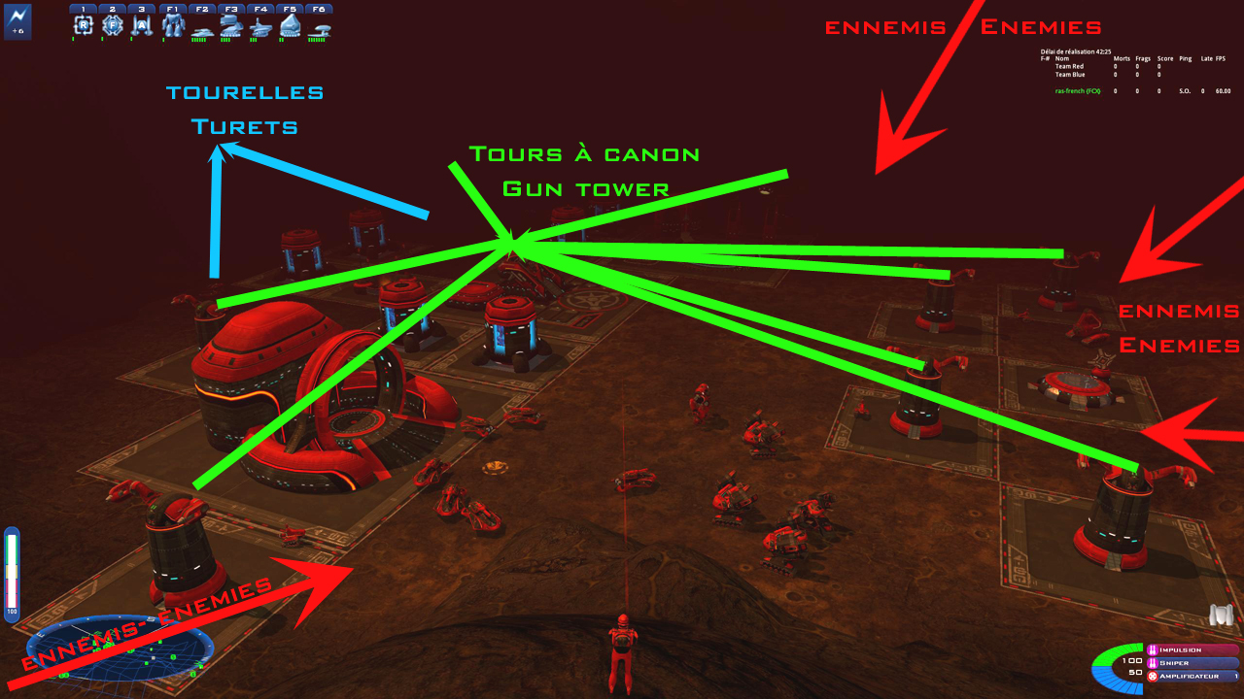

1. In red possible arrivals of enemies.
2. In green, all the gun towers: 2 at the rear of the base, 1 glued to the factory which also protects an improved well, one glued to the rep area. at the top in the middle of the image, 4 others positioned in front of the possible arrivals on the right and also protecting a nearby well.
With this arrangement, enemies take crossfire, very effective because the towers do not interfere with each other.
3. In blue, 2 turrets placed at the rear for a possible infiltrated enemy.
4. You will notice that the energies are dispersed 2 X 2, and that there are 6 in advance.
5. Also the significant space in front of the factory and buildings to allow smooth circulation.
6. The most observant will have noticed several repair trucks at the foot of the gun towers.
7. The "open" layout of the repair area (at the bottom), easy to access or send units to be repaired. In this regard, remember to place a Navigation Beacon in the middle of your repair area, very useful for sending your tired troops there.
8. All this will save you a lot of time that you would use otherwise: you will be more efficient!
9. Against the Scions you will be faced with the Archers. They often land high up on the surrounding hills.
A very effective solution is to position turrets on the hills around the base. Either your turrets will destroy the archers, or these archers will land further away, sometimes even too far away to shoot you.
The only condition: that the hills are not too steep for the turrets to climb.

Page 5
Various strategic advice.

“The first 5 minutes of a game generally determine its outcome.
The winner is usually the one who gets the most out of the first 5 minutes."

• In a strategic game, you start with a recycler and 40 resource units (scrap).
Build two scavengers right away, and grab the resources.
You can send one of the scavenger to collect the fragments, but don't forget to deploy him when they run out.

• Operation of resources:
The bar on the left of the screen indicates resources.
• In green, 40 storage units is your recycler.
It earns you 1 unit every 3 seconds.
• In yellow, 20 units of resources, it's an Extractor, 1 unit per second
• In red, 20 units of resources, it is an improved Extractor, 2 units per second.
Your extraction speed is not linked to the number of Extractors, your storage is!
Indeed, if you want to build an assault tank (70 fragments) with 2 Extractors and a recycler, the first 40 fragments will come in quickly (40 seconds, 20 if your Extractors are improved), on the other hand, the next 30 will come from your recycler, and you will therefore need 90 seconds!!!
• So, only build what your production reasonably allows.
• At the start of the game, with 2 Extractors, build a few light turrets to protect the deposits.
• Quickly deploy a third scavenger and make a builder.
• With three Extractors (there are generally 7 deposits per map, so you need 3 or 4 at the start of the game if you want to get by), Build an energy plant, and send your builder to the nearest deposit.
While he goes there, build a second builder to expand your base and protect it with gun turrets.
• If you are still too "light" in resources, one technique is to strengthen your defenses at the base and wait for enemy attacks. Each destroyed ship drops a resource that your scavengers will harvest.
• Near each deposit, build a relay bunker and two or three gun turrets, thus securing the area at the start of the game. A repair truck on the gun towers is also very useful.
Don't forget to provide enough power plants to power everything.
• Expand your base during your first builder's transits (don't let fragments pile up unnecessarily!) Also build repair trucks and send at least one to each gun turrets to repair them during attacks.
• Once the armory is built, walk into your factory and recycler.
Select the light panel at the back of the room, then each unit you want to upgrade.
For example, equip your scouts with machine guns, your light tanks with machine guns + SP-Stab….
So each unit built will have this configuration but will cost a little more.

Page 6

• If you have turrets deployed since the start of the game, they therefore have a standard configuration (minigun), as soon as you have an armory, make machine guns for these turrets by doing this: 3 (armory) 1 (rifles) 4 (machine gun) then target a turret with "space".
The machine gun will fall directly on the chosen turret.
You can also do this by entering the relay bunker, useful if you have units too far away.
• As you protect your deposits with cannon towers, send your obsolete light turrets to unprotected sites or on hills to protect yourself from archers
Arrange your turrets well so that there are no blind spots: a clever opponent will get behind your plunderer sheltered by the turrets, and will be able to destroy him without being hit.
• Do not attack your opponent's base at the start of the game, it is a waste of time, the most useful thing is to destroy his wells to deprive him of resources.
• Once you are well established, you can consider progressing through opposing defenses.
At the start of the game, the most effective unit is the mortar bike!
At 45 units, you can create uninterrupted assault waves of motorcycle mortars.
They can destroy a light turret without getting hit, and you can launch 5 or 6 mortar bike against a gun tower.
• The motor-mortars will suffer losses, but at their price it is not a problem, and the tower will be destroyed. Additionally, if you have sent raiders there, they will recover the resources dropped by your destroyed units.
• When clearing a site, be sure to have a builder nearby so you can immediately occupy the space.
• When the game is more advanced, the ultimate weapon for destroying cannon towers is the Assault Tank.
Build 4 or 5, accompany them with a maintenance vehicle to repair them if they are attacked.
An Assault Tank has a greater range than a gun tower, and can therefore destroy it safely and quickly.
You can also leave them on site to defend the area while waiting for your builder.
• Remember to never stay still if you are near the front, you would make an easy target for a sniper.
• If enemy pilots eject into your base, pick them up at their landing point. A lone pilot can easily lodge in the corners of your base, and will cause you to waste as much time as possible flushing him out while he damages your recycler or your units. The ideal is to leave 2 or 3 turrets, placed intelligently between the buildings, they will take care of getting rid of intruders.
• To lead the base, stay in your tank or on foot, you will have a better appreciation of the situation than by squatting in a relay bunker, even if it requires more practice.
• The relay bunker is useful when you are far from where you want to build.
It will save you from too much back and forth, and later, from managing several partners in very difficult MPIs or on very large maps.
• Place a beacon on the repair area, and send your damaged units there.
• Leave at least one repair vehicle at your base, near your recycler, just in case.
• If you or one of your pilots gets shot down, remember that you can build an empty scout for only 20 fragments.

Page 7

That's the main thing, with these tips you are equipped to play good games of Battlezone CC with friends or alone against the AI.
This advice is given on the principle of the I.S.D.F. faction.
For Scions, it's pretty much the same except that the energies are integrated into buildings during their construction.
You will find out for yourself by trying all the factions, it allows you to change your play style.
New players, welcome to Battlezone CC, and see you soon in multiplayer...

PS: Don't forget that other utilities, help documents, maps, mods, patches etc. are available for free download on my site
and online on steam in the Battlezone Community Hub
https://steamcommunity.com/app/624970/guides/?searchText=&browsefilter=trend&browsesort=creationorder&requiredtags%5B%5D=-1
Have Fun, Ras-French {FCX}

